Отчет по лабораторной работе №5 (Логические вентили)

Задание №1

**Логический элемент – «НЕ»**

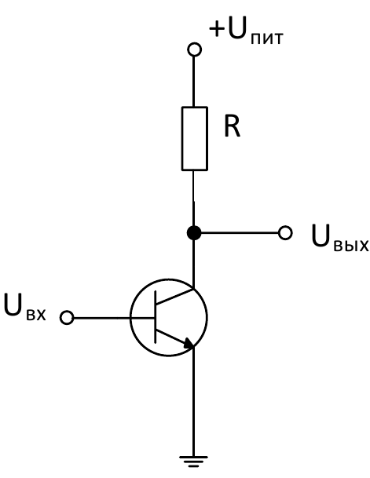

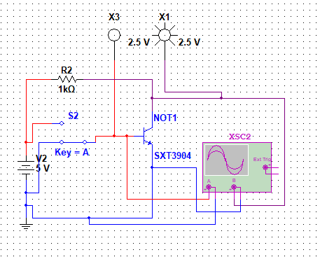

**Логический элемент – «ИЛИ»**

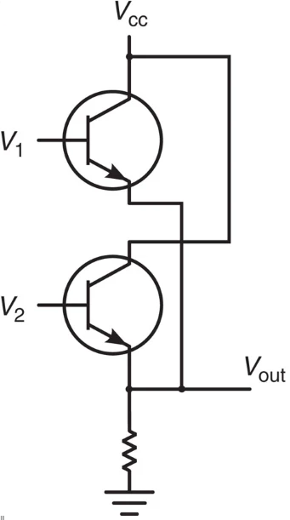

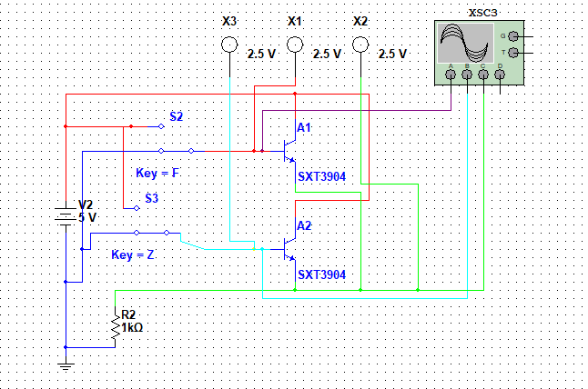

**Логический элемент – «И»**

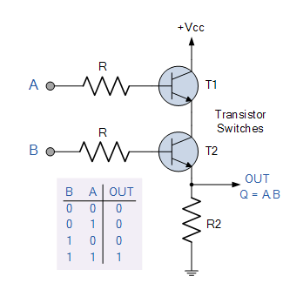

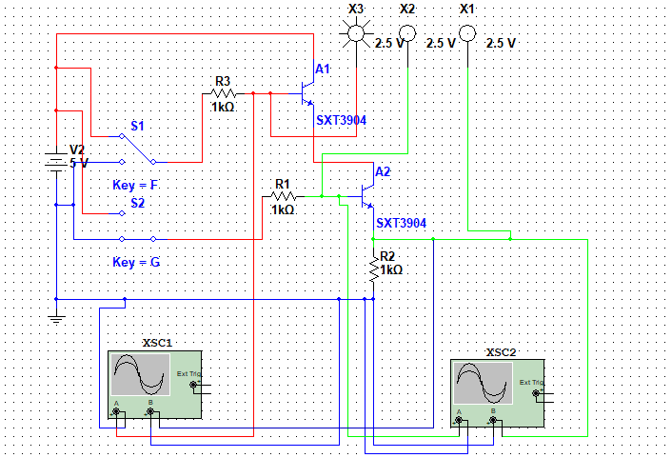

**Логический элемент – «ИЛИ-НЕ»**

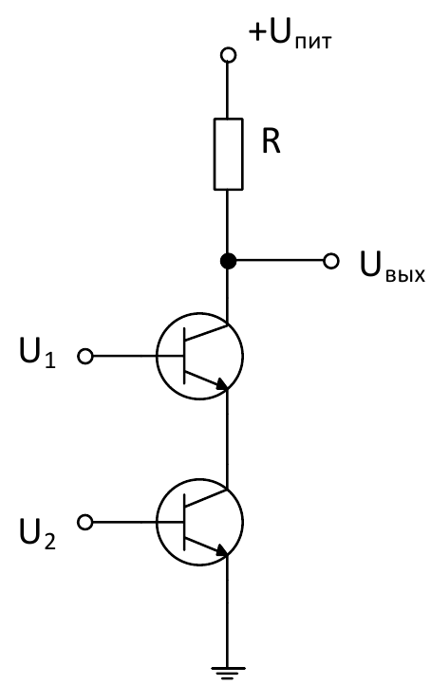

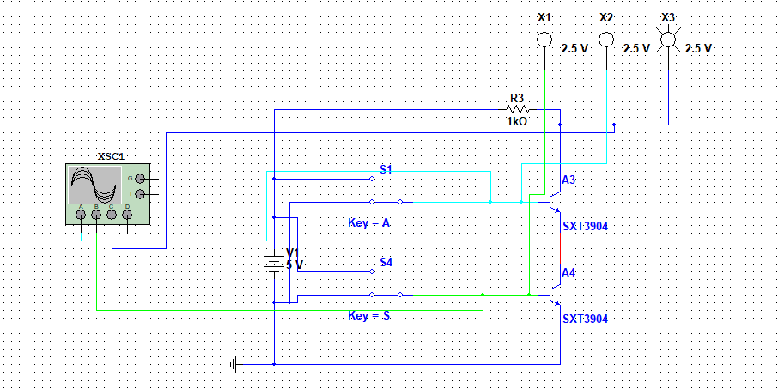

**Логический элемент – «И-НЕ»**

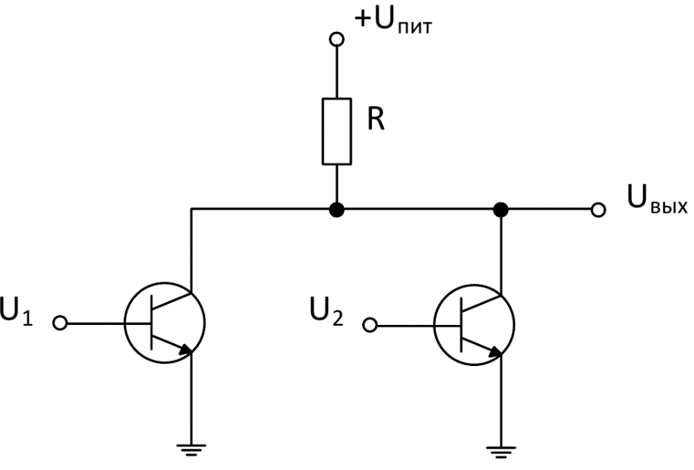

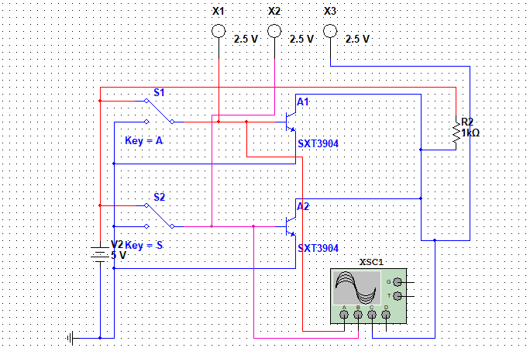

Задание №2

**Логический элемент – «НЕ»**

|  |  |  |
| --- | --- | --- |
| S2 | X3 | X1 |
| 1 | 1 | 0 |
| 0 | 0 | 1 |

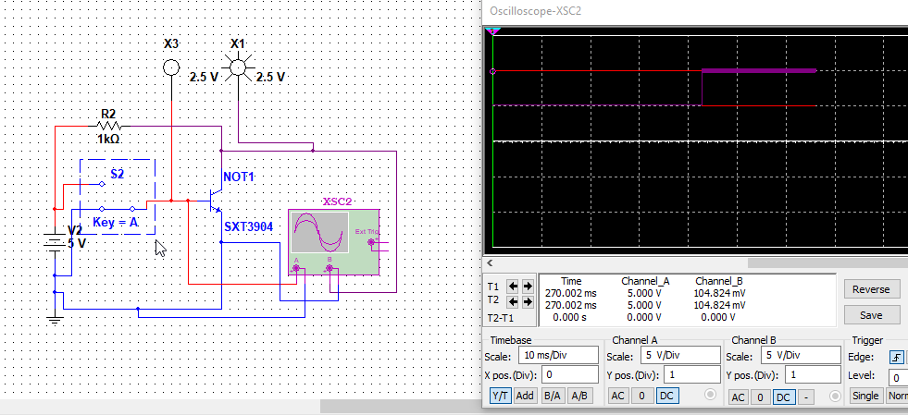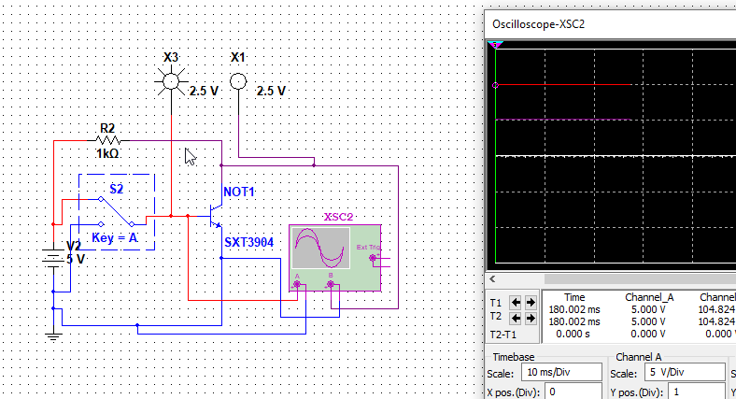

**Логический элемент – «ИЛИ»**

|  |  |  |  |  |
| --- | --- | --- | --- | --- |
| S2 | S3 | X1 | X2 | X3 |
| 0 | 0 | 0 | 0 | 0 |
| 0 | 1 | 0 | 1 | 1 |
| 1 | 0 | 1 | 1 | 0 |
| 1 | 1 | 1 | 1 | 1 |

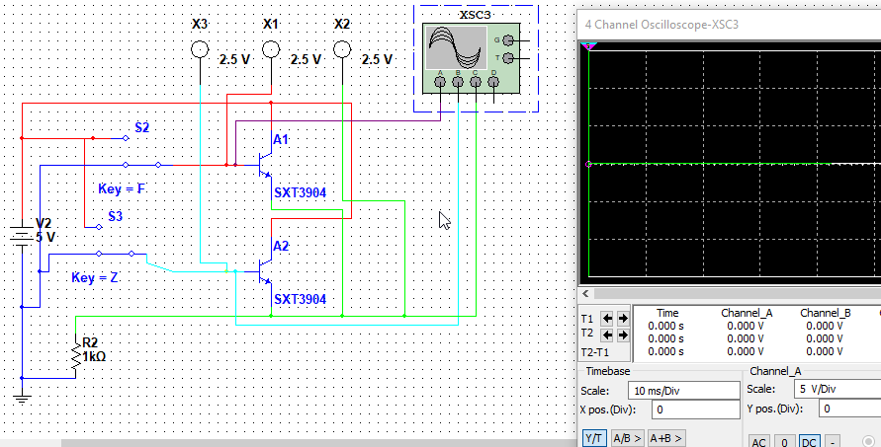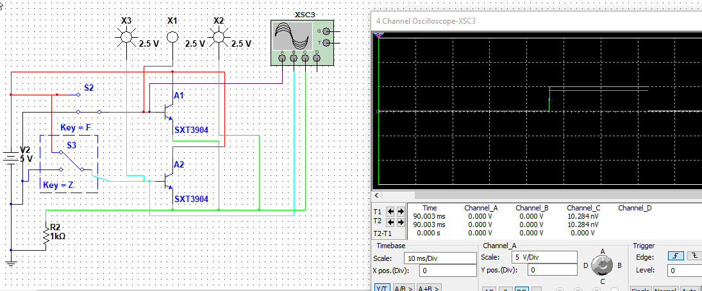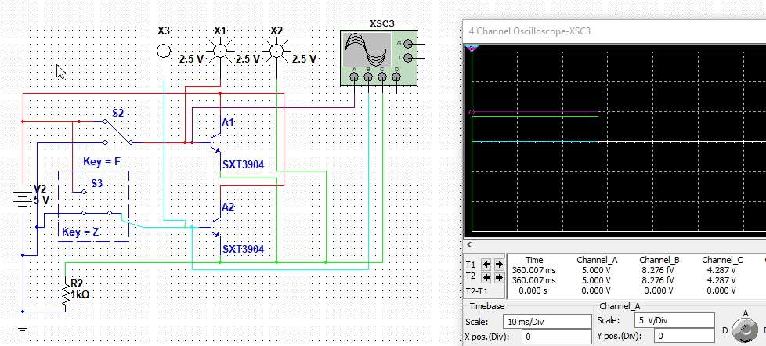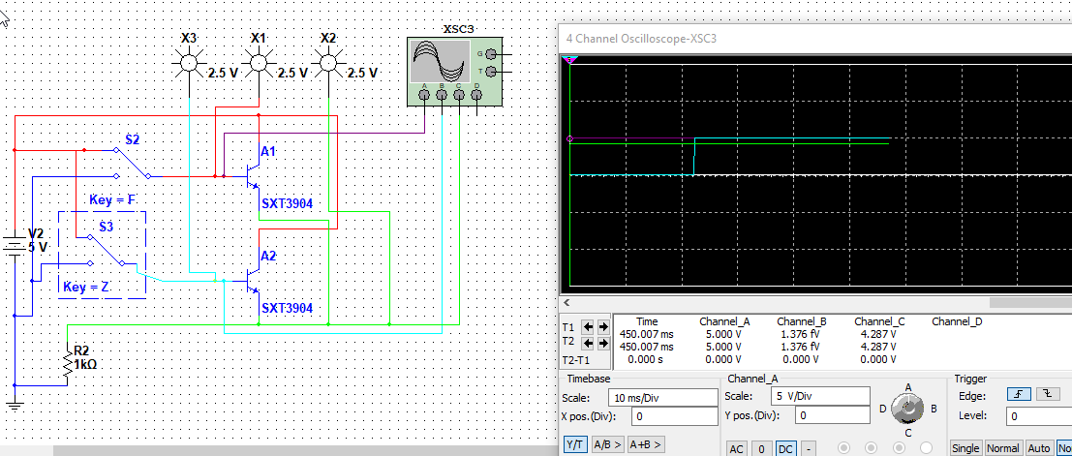

**Логический элемент – «И»**

|  |  |  |  |  |
| --- | --- | --- | --- | --- |
| S1 | S2 | X1 | X2 | X3 |
| 0 | 0 | 0 | 0 | 0 |
| 0 | 1 | 0 | 1 | 0 |
| 1 | 0 | 0 | 0 | 1 |
| 1 | 1 | 1 | 1 | 1 |

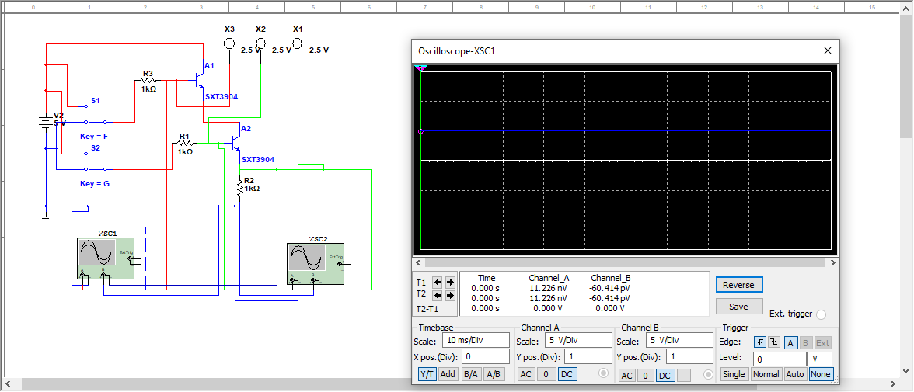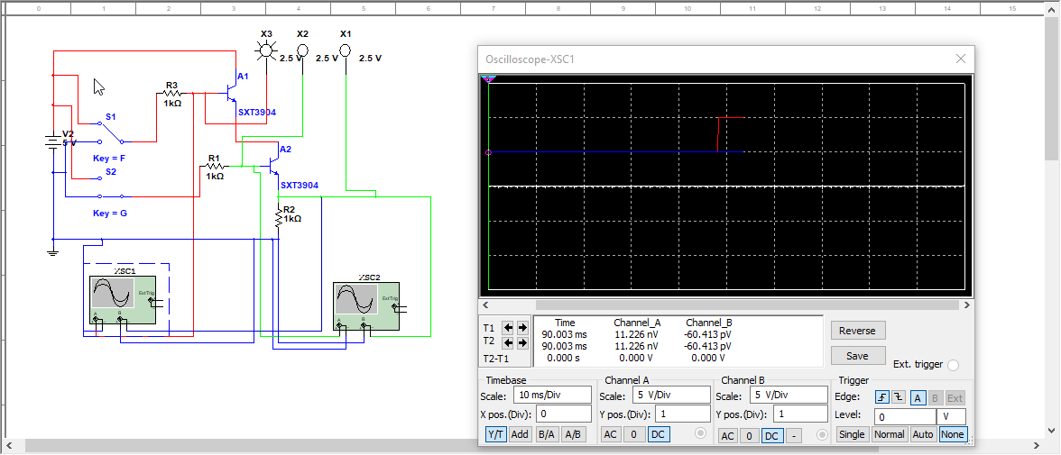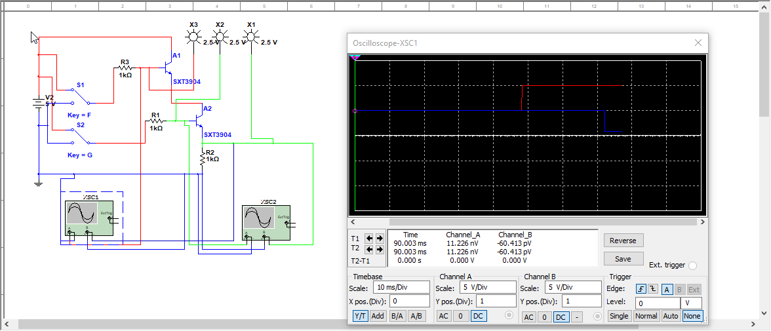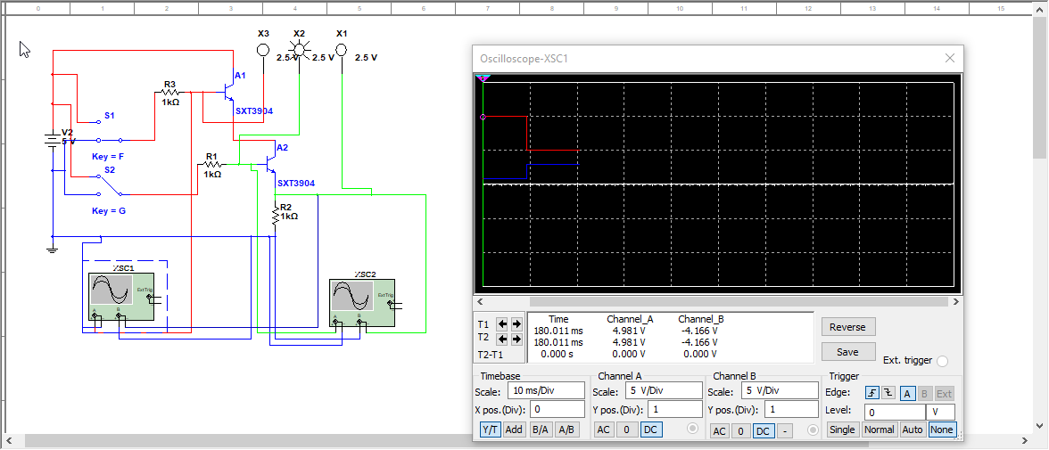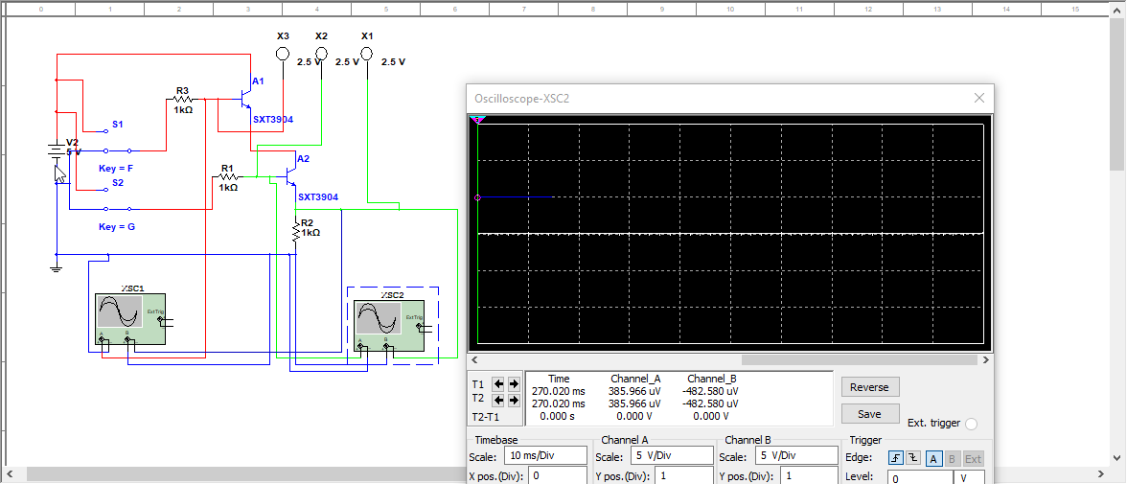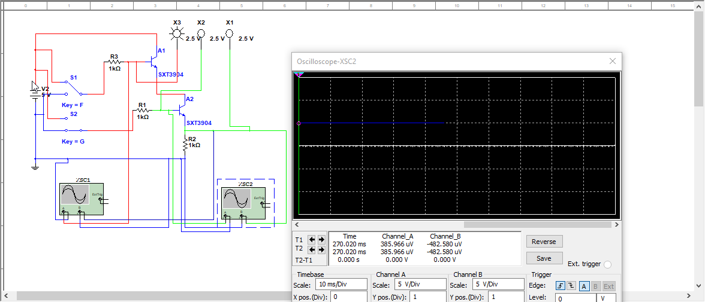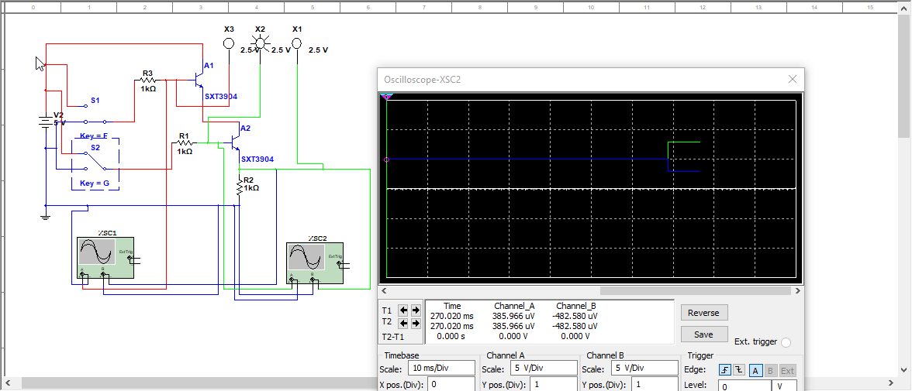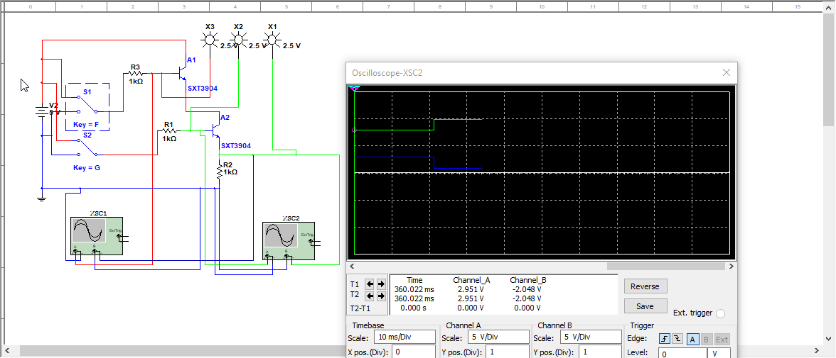

**Логический элемент – «ИЛИ-НЕ»**

|  |  |  |  |  |
| --- | --- | --- | --- | --- |
| S1 | S4 | X1 | X2 | X3 |
| 0 | 0 | 0 | 0 | 1 |
| 0 | 1 | 1 | 0 | 1 |
| 1 | 0 | 0 | 1 | 1 |
| 1 | 1 | 1 | 1 | 0 |

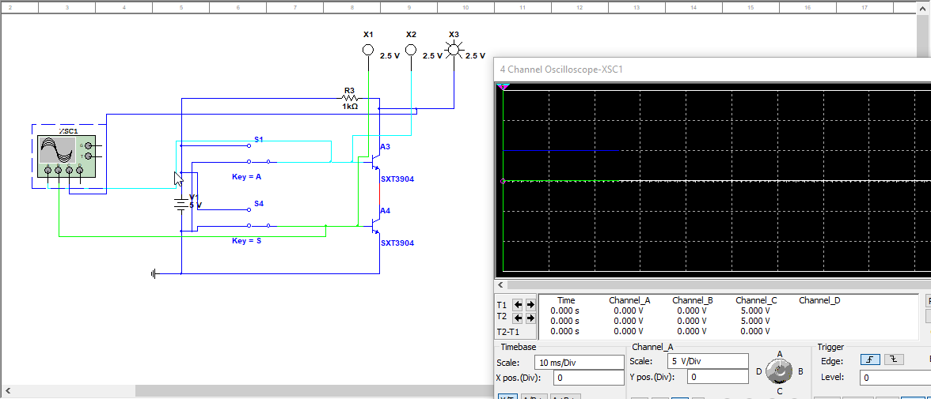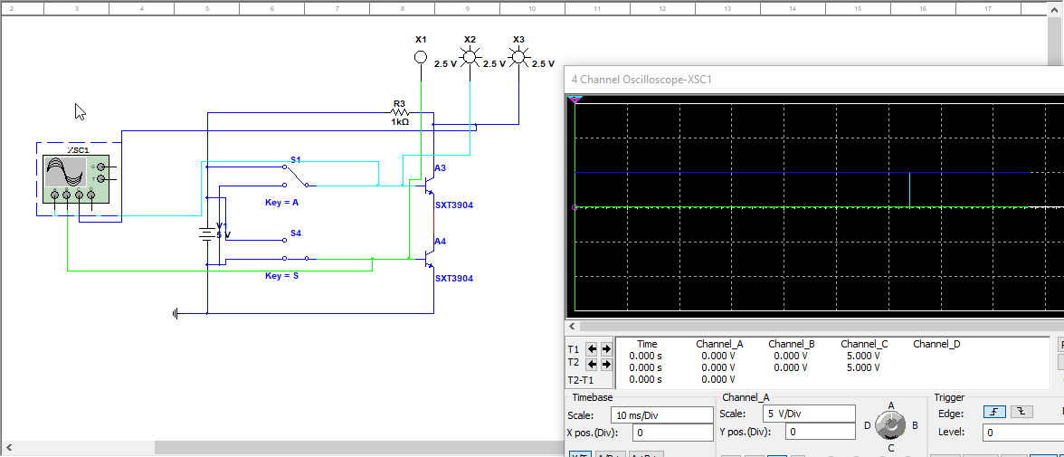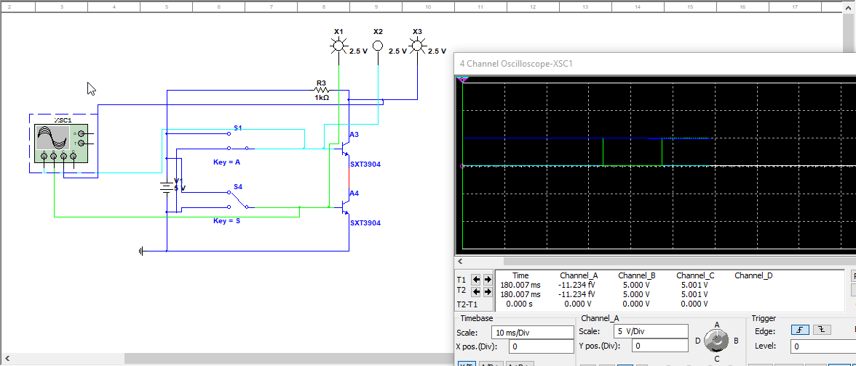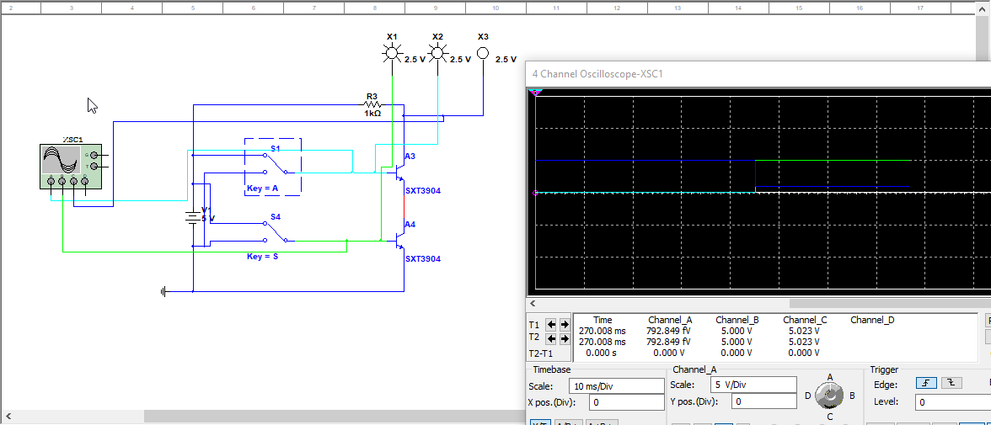

**Логический элемент – «И-НЕ»**

|  |  |  |  |  |
| --- | --- | --- | --- | --- |
| S1 | S2 | X1 | X2 | X3 |
| 0 | 0 | 0 | 0 | 1 |
| 0 | 1 | 0 | 1 | 0 |
| 1 | 0 | 1 | 0 | 0 |
| 1 | 1 | 1 | 1 | 0 |

